Google Data Analytics Capstone Project
Cyclistic Bike-Sharing Report:
The Insights on Casual Riders vs. Annual Members
Author: Thanh Le
Email: nhatthanhle2014@gmail.com
Date: 7/21/2022

STEP 1: ASK
- What is the problem you are trying to solve? Determine the specific tasks to solve the problem.
I was assigned by Lily Moreno – Director of Marketing to analyze Cyclistic’s usage data of casual and annual riders to explore the insights and provide recommendations to the stakeholders on converting casual riders to annual subscribers.
To achieve the objectives, my team will need to identify the marketing strategies published to the marketing channel casual riders might want to consider.
- What metrics will you use to measure the given dataset?
- Identify the most used ride type based on the recent 12 months of data.
- Forecast usage behavior of riders and members on a 7-day cycle.
- Identify the most used start and end stations.
- Who are the stakeholders? Who is the audience?
The stakeholders and audiences are Cyclistic Executive team including Lily Moreno. Therefore, the presentation for the meeting must be descriptive, clarified, detailed, and supported by visualizations to make the recommendations strong and reliable to the Executive team.
- How can your insights impact the business decision?
The insights of the analysis will provide the recommendations that are supported by visualization that will help stakeholders make up their minds on the marketing strategies by the end of this report
- A clear statement of the business tasks.
In this case study, we will explore and analyze Cyclistic’s usage data of casual riders and annual members. The data will be analyzed based on the metrics of the most used ride type, usage behavior of riders on the 7-day cycle, and the most used start and end stations. From there, we can generate support visualizations to strengthen our recommendations to stakeholders on how to convert casual riders to annual members.
STEP 2: PREPARE
- Where was your data located? How is the data organized?
The data is located on Amazon Web Server and owned by Cyclistic (first-party data).
The data is stored monthly in CSV file format. Dataset columns include ride ID, ridable types, started time, ended time, start station, end station, start and end latitude and longitude, and member types.
- Are there issues with bias or credibility in this data? Does your data ROCCC?
The data seems quite reliable, the only issue was that they missed about 16% of start and end stations, but we can simply use longitude and latitude to match the station. The data is also the first party so it’s original so there is no need to cite any sources for the data as well. The data is comprehensive and current because it’s been consistently updated since 2013. In conclusion, this data is ROCCC.
- How are you addressing licensing, privacy, security, and accessibility?
Downloaded data will be stored on my computer hard drive and backed up to an external hard drive. Raw data will be restricted to anyone else and the presentation will only show visualizations and filtered tables.
- How did you verify the data’s integrity?
I double-checked the latitude and longitude provided in the dataset to confirm if this data is accurate and integrity.
- Are there any problems with the data?
- Some ride IDs have a number format problem.
- About 16% of missing data is in the start station and end station columns.

STEP 3: PROCESS
- Tasks performed on Microsoft Excel:
- Download and unzip files into the working folder on my computer using the appropriate file naming method.
- Back up all raw data in an external hard drive.
- Open each .CSV file to start cleaning data: remove all duplicates, turn on the data filter, and check each column to see if there is any unusual error. For example, check the number of ridable types, member or casual, the data format for each column, etc.
- Create another column to calculate ride length by subtracting ended time from started time. Aggerate a function to identify the day of the week based on the date provided in the started time column. (Sunday will be assigned to number 1 and Saturday is number 7)
- Ensure data is cleaned to proceed, then save as .XLS file into the separated folder. Do the same steps for the rest of the data.
- Tasks performed on Microsoft SQL Server:
- Imported all Excel data into the SQL Server for further analysis.
- Create a temporary table to combine all 12 months’ data into one dataset. Also, filter out unnecessary data such as start station and end station ID.
- Perform statistical summary on the new table:
  - 13 columns are remaining and there is a total of 5,900,385 rows of records.
- Exclude NULL values in in start_station_name and end_station_name columns, the remaining records is 4,678,871 (about 22% data has been excluded)
- Inspect anomalies in data by checking distinct values and min/max values in all columns.
- There is an issue with the ride_length column that we created in Excel that the format is not what we want to see while importing data. Fixed by converting date-time format from date and time to time only.

STEPS 4&5: ANALYZE AND SHARE
Analysis 1: Number of bikes borrowed on each day of the week
Statistical Summary:
Total rides: 5,900,385
Members: 3,342,158 (56.64%)
Casual Users: 2,558,227 (43.36%)
Table 1: After combining all data into 1 large dataset, I ran the query to return the total count of bikes borrowed per day of the week with 1 = ‘Sunday’ to 7 = ‘Saturday’. Based on the number from Table 1, bikes are heavily borrowed starting from Thursday to Sunday. The highest number of bikes borrowed is on Saturday with 979,726 times throughout the year. This table will be visualized in Microsoft Excel

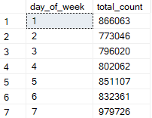
Table 1: Total count of bikes borrowed per day of the week
Figure 1: The visualization shows us that Saturday is the most active day with a total of 979,726 bikes borrowed by both members and casual users throughout 12 months. However, we will need to compare casual users and members on a separate chart to compare their differences.

Figure 1: Total bikes borrowed per day

Figure 2: This graph can easily compare the two types of customers. While casual users are more actively using the service on weekends, the members tend to hire bikes on regular days during the week and hire less on the weekends.
Based on this information, we can conclude that casual users are most likely to be tourists or people who hang out on weekends that need quick and affordable public transportation that is high mobility such as bikes. On the other hand, annual members are residents that use bikes to travel around the area daily.

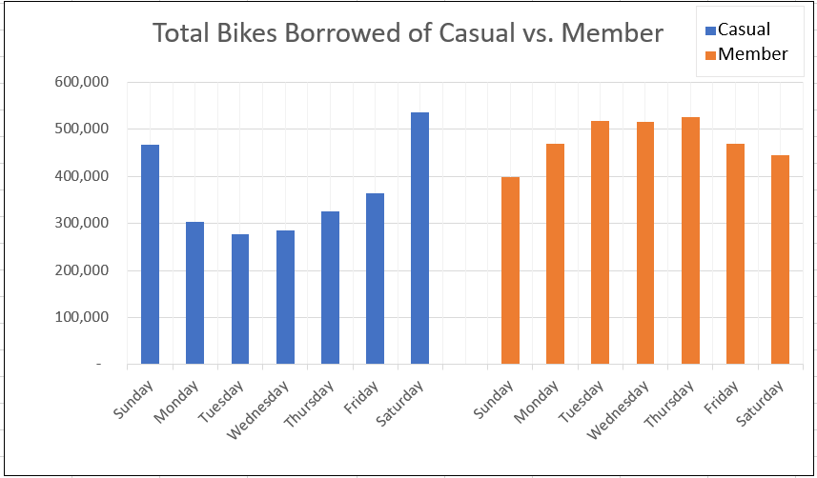
Figure 2: Total Bikes Borrowed of Casual vs. Member

Next, we will look further into different types of bikes and their usage per day. We will also compare member and casual users on which type of bikes they prefer to use.

Figures 3&4: The usage of classic bikes by the annual member is much higher than electric bikes up to 30.5%. For casual users, classic bikes and electric bike usage are almost similar, the only difference is that there are peaks in the usage of classic bikes on the weekends. Docked bikes are rarely used by casual users as well, classic bikes usage is about 80% more than docked bikes.

Figure 3: Bike types usage by members per day

Figure 4: Bike types usage by casual users per day
Overall, the most dominant type of bike that most users prefer is classic bikes, followed by electric bikes. Docked bikes are the least popular of all three types and member users don’t use them at all.
Compared to member users, casual users’ classic and electric bike usage is less than member’s usage during the week but comes very close during weekends because of the peaks in bike usage of casual users.
After this analysis, we will analyze the ride length difference between the two types of customers.

Analysis 2: Ride length differences between members and casual users
Tables 2&3: There is a big difference in both average ride length and max ride length between member users and casual users. The casual users tend to use bikes longer than member users by 15-20 minutes, no matter if it was on regular days or weekends.
Casual users also have cases that borrowed bikes for longer than a week. Based on the data we collected, some casual users borrowed bikes for 17 days to 28 days maximum while members borrowed bikes maximum of more than a day.
We can conclude that in some cases, casual users are willing to pay the bike rent fees for a month. Therefore, monthly or daily membership options might influence casual users to convert.

member_casual | day_of_week | average_ride_length | max_ride_length
casual | Sunday | 34 | 41629
casual | Monday | 30 | 31031
casual | Tuesday | 25 | 25007
casual | Wednesday | 25 | 35820
casual | Thursday | 26 | 41645
casual | Friday | 27 | 38685
casual | Saturday | 31 | 40724
Table 2: Casual users’ ride length per day (in minutes)
member_casual | day_of_week | average_ride_length_by_day | max_ride_length
member | Sunday | 14 | 1500
member | Monday | 12 | 1500
member | Tuesday | 11 | 1500
member | Wednesday | 11 | 1500
member | Thursday | 12 | 1500
member | Friday | 12 | 1500
member | Saturday | 14 | 1559
Table 3: Annual members’ ride length per day (in minutes)
However, we will need more information on pricing and budgeting to establish new options for our apps. Also, we will have to gather more data on how much customers pay for a membership versus hourly rent.
In the next part, we will focus on the location of the stations and how they can impact the casual users to join our membership.

Analysis 3: Start stations and end stations distribution and how they impact customers.
Figure 5: On the left, the most used start stations are clustered in the center of Chicago. There are larger bubbles are presenting on the map, which means those locations might be special and we will look at them in further analysis. Also, the bubbles are medium size and scattered in the sub-urban area.
On the right side, the end stations are clustered heavier than the start stations but with smaller bubbles in the center of the city. Outside Chicago, the bubbles are less scattered than the start stations.
Both start and end stations in the Southern area are distributed quite similarly.
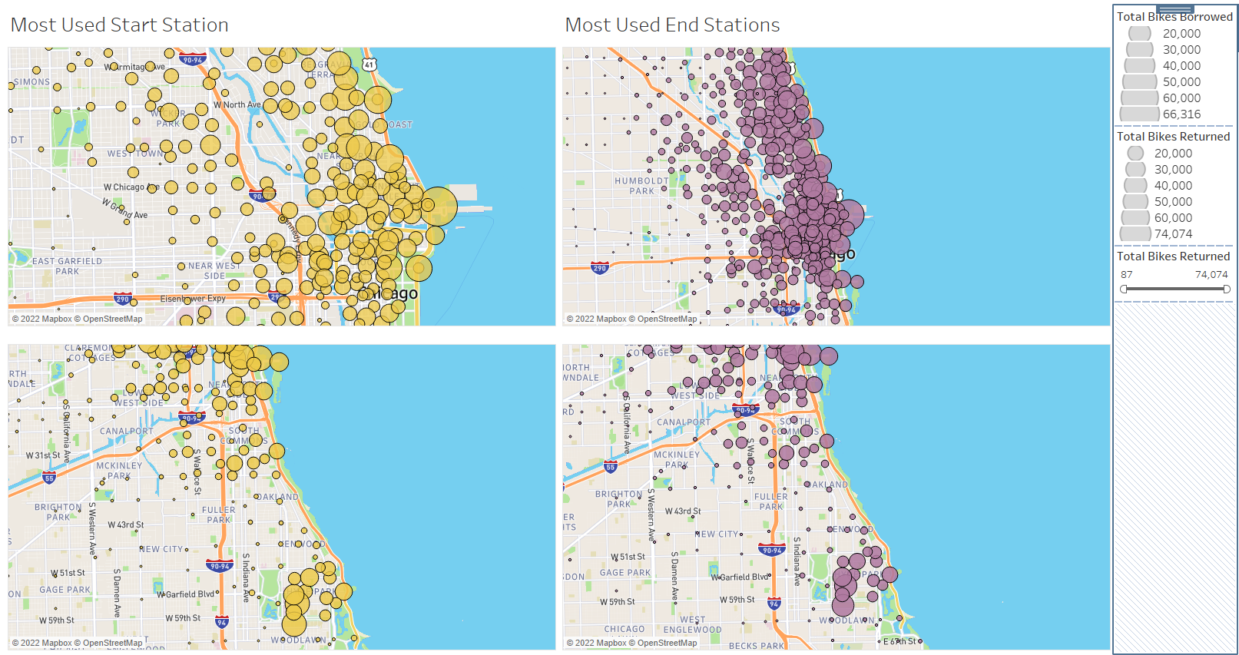
Figure 5: Start and end stations distribution (only 1000 most used stations were used for these visualizations)

We will take a closer look at the center area of Chicago and narrow down the number of stations (around the top 20 most used stations) to have a better view of each area of the city.
Figure 6: The figure below only shows stations with more than 20,000 check-ins to present the top stations that customers regularly visit.
The start stations map shows that people tend to visit the tourist attraction area in Chicago such as the theater, the aquarium, the Lake Point Tower, the Millennium Park, and the Downtown area. The stations in that area have the highest visit counts compared to the rest.
On the other hand, the end stations map is showing that people tend to drop off their bikes near public transport stations such as metros or trains. The bubbles are not only focused on tourist attraction places, but also the public transport stations area.
With this information, we might consider putting up our advertisements around this area to influence casual users.
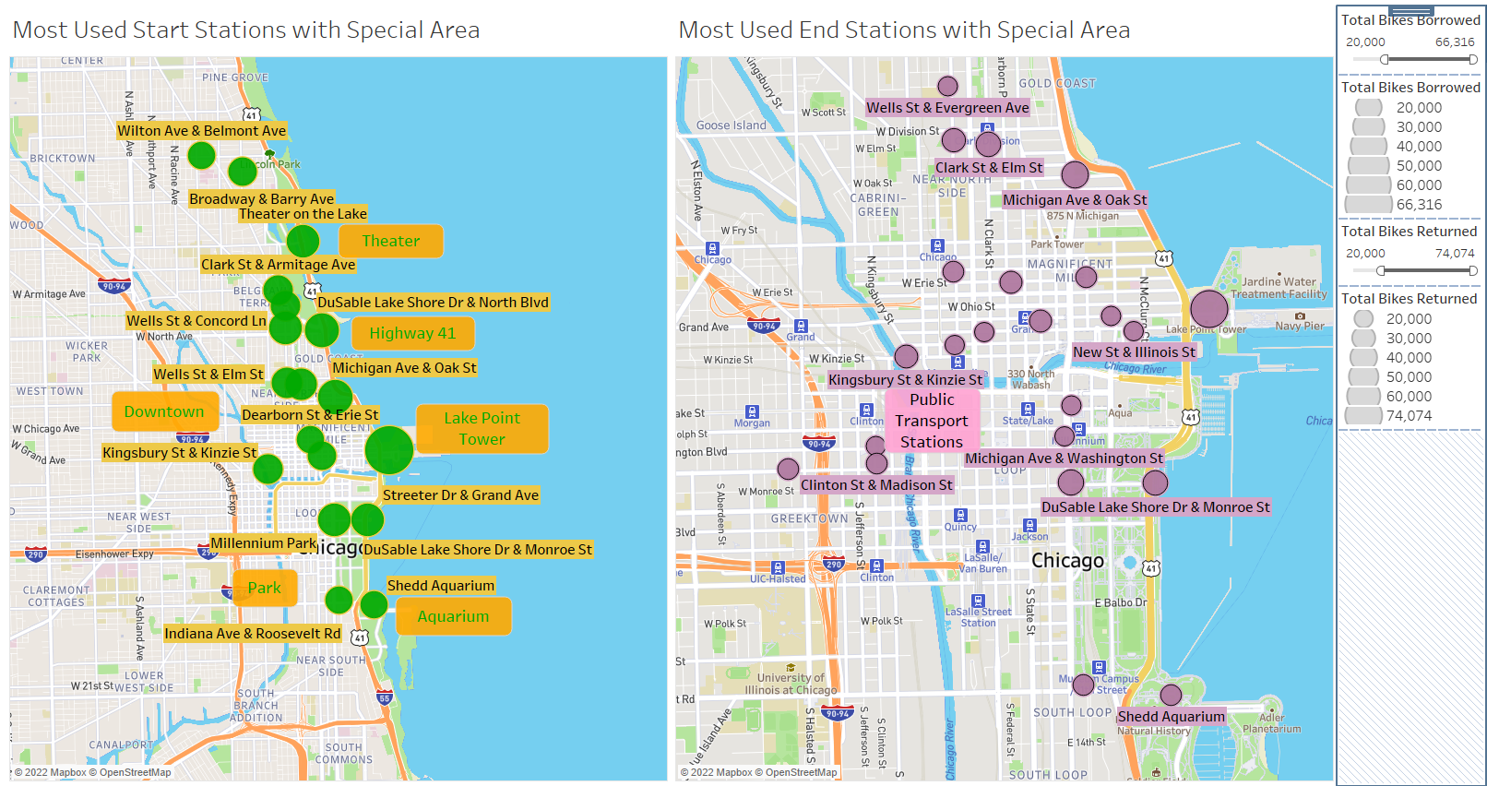
Figure 6: Most used start and end stations in the center of Chicago

STEP 6: ACT
Recommendations/ Next Steps:
- Conduct more surveys and interviews with casual users to gather more data for further analysis.
We already knew that casual users tend to borrow bikes more heavily during weekends and they also have longer usage time compared to the members. However, we can’t firmly conclude that most of them are tourists. Therefore, we will need to gather more data to either secure our assumption or discover new possibilities.
- Provide other membership options such as monthly or daily passes.
There are cases where casual users borrowed bikes for a very long time but they didn’t choose to buy the membership. We will need to find out if pricing is an issue for casual riders or if our membership options are not considered cost-efficient for casual riders. From there, we might consider adding more options for casual users such as monthly membership or daily passes.
- Putting up advertisements on the most used station areas.
Areas with the most used stations are perfect places for our ads. We should start running ads in the tourist attraction locations such as the theater, the aquarium, the Lake Point Tower, the Millennium Park, and the Downtown area. Also, we should consider putting our ads in public transport stations such as metros or train stations to remind users whenever they drop off their bikes. Last but not least, putting ads along Highway 41 is also not a bad idea since the most used start stations are located along the highway itself.

